INTEGRAL UNIVERSITY, LUCKNOW

**Department of Computer Science & Engineering**

**B. Tech. CSE**

**(Cloud Technology and Information Security)**

**Session 2021-22**

**Project Synopsis**

**On**

**Snake Game**

**Subject Code: CS399**

**Subject Name: Mini Project-I**

**Submitted By: Submitted To**

**Enroll No: 1900101251 Mrs. Parisha Ma’am**

**Name: Md Ahtisham**

**Roll Num: 1901163007**

**Year/Semester: III/6TH**



**Table of Content**

|  |  |  |
| --- | --- | --- |
| **S. No** | **Title** | **Page No.** |
| 1 | Abstract | 3 |
| 2 | Introduction | 4 |
| 3 | Objective | 5 |
| 4 | Tool and technology | 6 |
| 5 | Hardware requirements | 7 |
| 6 | Proposed System | 8 |
| 7 | Flow diagram | 9 |
| 8 | Pygame Pros and Cons | 10 |
| 9 | Future of Scope of this Project | 11 |
| 10 | Conclusion | 12 |
| 11 | References | 13 |
|  |  |  |

**Abstract**

This project aims to bring the fun and simplicity of snake game.

The rules and regulation of the game are well-known as the game. The case study meant for implementing this game without losing its attraction. This game comes with a single player mode. This Snake Game in python is an easy game for all. The graphic of the game play is good and smooth to control for the users. Talking approximately the game play of the system, the game strategy are too easy, all you need to do only east food and size will increase then eat another food. This project explores a new dimension in the traditional snake game to make it more interesting.

**Introduction**

Snake is an older classic computer game. It was first created at the end of 70s. Later on it was brought to PCs. With this game the player controls the snake. The aim is to east as many pears as possible. Every time the snake eats and body grows. The particular snake must avoid the wall space and its own body.

The dimensions of each of the joints of a snake are 10px. The particular snake is controlled using the cursor keys. Initially, the particular snake has three important joints. If the game is finished, the particular “Game Over” message will be displayed in the middle of the table

**Objective**

The objective of our game is to maximize the score. The above mentioned simple strategy may keep the snake alive, but without moving toward the food efficiently it cannot get a high score. This project aims to bring the fun and simplicity of snake game with some feature. The objective of this python project is to build a snake game project. In this python project, the player has to move snake so it touches the food. If the snake touches itself or the border of the game then the game will over.

**Tool and Technologies**

**Programming Language :** Python

**Python**- Python is an interpreted , high-level, general-purpose programming language. Created by Guido van Rossum and first released in 1991, Python has a design philosophy emphasizes code readability, using significant whitespace. It provides construct that enable clear programming on both small and large scales.

**GUI :** Pygame

**Py -Game :**  Pygame is a cross-platform set of Python Modules designed for writing video games. It includes computer graphics and sound libraries designed to be used with the Python programming language.

* **Random:** Random module is used to generate random number

**Prerequisites for Pygame**

Install Pygame: 1. Install through pip

2 . Installing through an IDE

**IDE :** Visual Studio

**Visual Studio:**  An Integrated development environment (IDE) is a feature-rich program that supports many aspect of software development. The Visual Studio IDE is a creative launching pad that you can use to edit , debug, and build code and then publish an app. Visuals Studio includes compiler , code completion tools, graphical designer, and many more feature to enhance the software development process.

**Hardware Requirements**

**Processor:** Intel P4 1.5Ghz or Above

**Ram:**  2 GB

**Hard Disk:** 80 GB

**Monitor :** 14 Inch

**Controller :** Keyboard

**Proposed System**

Proposed system will overcome the drawback of existing system. Existing system is manual and available appointment applications are not user friendly. Proposed system is computerized and user friendly. The proposed system has many advantages.

**Flow Chart**

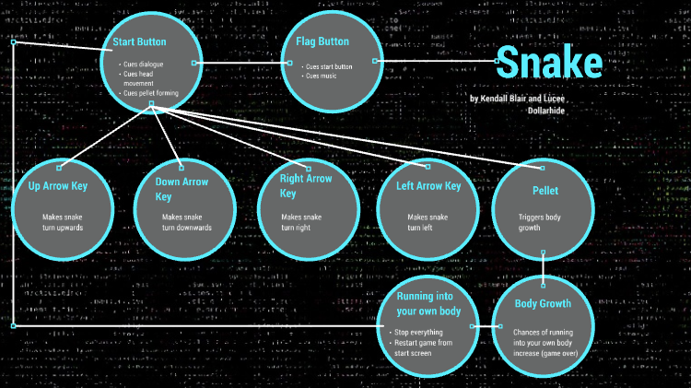

**Pygame Pros and Cons**

**Pros :**

* It is genuinely easy to utilize and run on any environment
* Exhaustive docs made simple and fast
* We can implement pygame only by one long giant block of source code
* Pygame accompamies less gathering required
* Heaps of individual who have utilized SDL, which Pygame depend on few aspect

**Cons:**

* Python is additionally not really extremely superior execution, which could conceivably be an issue
* Pygame is not equipment sped up and will battle with enormous quantities of spirits
* In pygame there a function which just handle 2D design for you
* Pygame does not work with it, apparently because of particular of its C copies

**Future of Scope of this Project**

Our project will be able to implement in future after making some changes and modification as we make our project at a very low level. So the modifications that can be done in our project are:

IT can be made with good graphics

And we can add more options

**Conclusion**

We learned how to create the snake game in python along with concepts such as collision detection, image loading and event handling. Many things could be added to this little toy but this server as very simple example.

The good thing about this game and our solution is that it is very simple. The approach is pretty simple and easy to understand even for beginners. This game could run on many platforms.

There can be many more features which can be added to this game to make it more interactive and interesting.

**References**

[www.pythonprogramming.net](http://www.pythonprogramming.net)

[www.w3schools.com](http://www.w3schools.com)

[www.geeksforgeeks.org](http://www.geeksforgeeks.org)